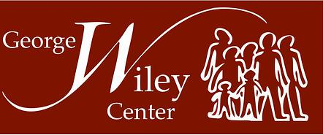

Know Your Utility Rights
6:30-8:30pm, Thursday, April 23rd
George Wiley Center
32 East Ave
Pawtucket, RI 02860
Have you received a notice for the termination of your utility services?
Are you concerned about possibly facing shut-off this spring or summer? Do you know what you can do to exercise your rights to stop-shut offs?
Are you interested in helping to stop shut-offs in Rhode Island?

Come to this informational “Know Your Utility Rights” clinic to learn about your rights as a utility consumer in Rhode Island and how you can avoid having your electric and/or gas shut-off. The George Wiley Center staff and volunteers will listen to your issues and you will learn about what you can do to defend your rights and stop shut-offs at your home and in our communities.

For over 30 years the George Wiley Center has been fighting shut offs and organizing to increase protections for utility consumers in Rhode Island. We strive to make sure that utility consumers have a say in decisions that impact us. Attend this meeting and help us spread the word about ways we can use our rights that have been won over years of struggle.

For more information contact:
Camilo Viveiros, George Wiley Center 401-728-5555 camiloviveiros@gmail.com
www.georgewileycenter.org
(From Providence bus #1 stops in front of the George Wiley Center)

